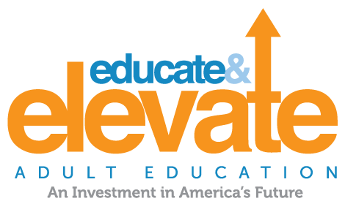
Legislator Key Facts:
The Business Case For Adult Education

America Has a Skills Gap

In a recent survey, 92% of business leaders thought that U.S. workers were lacking the necessary skills.

By 2018, 63% of all U.S. jobs will require education beyond high school. Yet, nearly half of the U.S. workforce—about 88 million of 188 million adults aged 18 to 64—has only a high school education or less, and/or low English proficiency.

Adult Education is a Key On-Ramp for Workers to Reach Middle-Skill Jobs

More than half of all jobs (54%) in the U.S. today are middle-skill jobs that require more than a high school diploma, but not a four year degree. Yet only 44% of workers are trained to the middle-skill level.

Educating motivated students with the skills that companies need can provide qualified candidates for hard to fill positions.
We can’t wait for today’s K-12 Students to fill that gap

In 2017, 36 million adults in the U.S. have limited English or reading skills and more than 60 million can’t perform simple math.

With Adult Education we can train these students to fill the jobs industry needs today.
Adult Education is Good for Business

By 2020, the American Action Forum projects that the U.S. will be short an estimated 7.5 million private sector workers across all skill levels.

Companies miss out on growth opportunities, product development suffers, and profits stagnate without a skilled national workforce. America needs an “all hands on deck” approach to bring every available worker to the labor pool.

Adult Education brings businesses options by preparing existing workers with competing life and family responsibilities with the skills that companies need through flexible classrooms and curriculum.

Supporting Adult Education supports the economy

Adult Education is a smart investment. We need all available workers ready to help our country compete.

Unfortunately, since 2001, funding for Adult Education, when adjusted for inflation, has fallen by 25.3%. Proposed additional cuts to education funding in 2018 will have a substantial impact on adult education.

1.5 million students are enrolled in Adult Education programs, down 44% percent due to funding cuts.

Increased Participation in Adult Education Reduces Spending and Increases Revenues

A person with a high school diploma or equivalent earns an average of $9,620 more per year than a non-graduate.

Adults with a high school degree were more likely to work full time and average 20% higher earnings ($30,000) well above the poverty line for a family of four.
Safer and Stronger Communities

Low-skilled adults are:
- 2x more likely to be unemployed;
- 3x more likely to be in poverty;
- 4x more likely to be in poor health; and
- 8x more likely to be incarcerated.

Educating adults creates stronger communities. Higher education levels are correlated with lower rates of chronic diseases like diabetes and asthma, and a mother’s education level is the highest determinate of a child’s academic success.

Inmate participation in adult education reduces recidivism by 29%.

Invest in Adult Education

We urge you to support funding Adult Education at the $649 million level as called for in the Workforce Innovation and Opportunity Act which was enacted in 2014. Help us build a strong economy. For more information, go to EducateandElevate.org.

