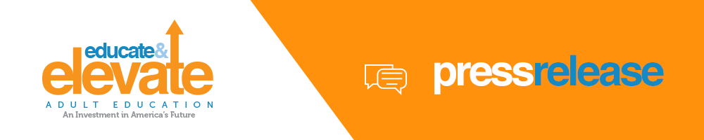
FOR IMMEDIATE RELEASE
[INSERT DATE HERE]
[INSERT CONTACT INFORMATION HERE]

[YOUR ORGANIZATION NAME] JOINS EDUCATE & ELEVATE CAMPAIGN TO SUPPORT INVESTMENTS IN ADULT EDUCATION

[Insert your city and state] – [insert your organization’s name] joins more than 55,000 adult educators in a new national campaign, called Educate & Elevate, that proactively educates policy makers about the importance of Adult Education and how it is an investment in America’s future.

By 2018, 63% of all U.S. jobs will require education beyond high school. Yet, nearly half of the U.S. workforce—about 88 million adults aged 18 to 64—has only a high school education or less, and/or low English proficiency. Adult Education helps to close this gap and provide workers with the skills needed for the jobs of today and tomorrow. Cuts in state and national budgets threaten adult education and can have a serious impact on the vibrancy of our city/state.

“Adult education is uniquely situated to address the needs of our regional employers,” said (insert name and title of local leader). “Educating motivated students will support our local businesses in creating jobs and filling positions, so we are urging legislators to fund Adult Education at the $649 million level as called for in the Workforce Innovation and Opportunity Act enacted in 2014.”

More than [insert # for your region] people are enrolled in Adult Education courses across [insert your state/region]. One of those adult learners in our local community is (name of learner). [Insert success story that includes: name, age and background of subject, their job prior to attending adult education classes, what classes they took and their job after attending adult education classes,]

The Educate & Elevate campaign seeks to empower students, educators, businesses and other advocates nationwide to raise the profile of Adult Education on Capitol Hill and in local communities throughout the nation.

The campaign website offers advocates tools and resources, infographics, videos, fact sheets and success stories to share with elected officials. Learn more about how Adult Education elevates career and college readiness at EducateandElevate.org.

###
(Insert organization’s byline)

