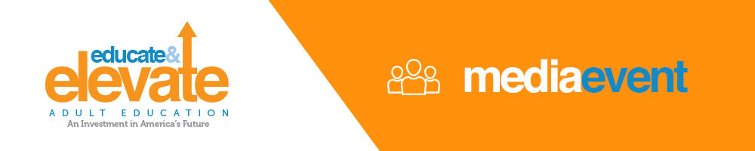

FOR IMMEDIATE RELEASE
[INSERT DATE HERE]
[INSERT CONTACT INFORMATION HERE]

[Insert your organization name] Celebrates Educate & Elevate National Campaign with Adult Education Event
What: Insert information about event
Who: Insert information about who will be speaking, facilitating, attending, and/or providing interviews
When: Insert date/time
Where: Insert venue location
Why: Adult Education strengthens our community, increases the productivity of local businesses and makes our city/state safer. Adults with a high school education are less likely to rely on government safety net programs, and are prepared to fill jobs right here in our community. Cuts in state and national budgets threaten adult education and can have a serious impact on the vibrancy of our city/state.
(Insert name of event) is part of the National Educate & Elevate campaign that drives awareness of the impact Adult Education has on the whole community and our ability to thrive in the 21st century.
PHOTO OPPS: Insert who will be available for photos and interviews
###

